**Temperature and Humidity**

**INPUT CODE:**

temp=87

humid=95

if temp>=80:

if humid>=90:

print("Its hot and humid")

print("Buzzer")

else:

print("Its not humid")

**OUTPUT SCREEN:**

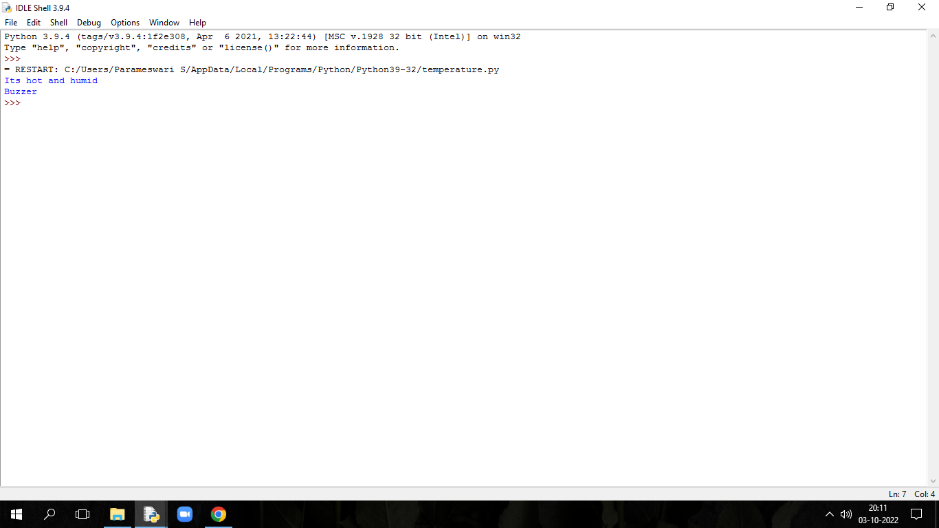

**M.J.MAKESH**

**961819106036**

**Ponjesly College Of Engineering**